Chapter 19, Solution 43.

- To find 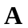 and 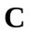, consider the network in Fig. (a).
Z
+
−
I₁
I₂
+
V₂
−
V₁
(a)

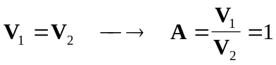

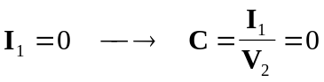

To get  and , consider the circuit in Fig. (b).
+
V₂ = 0
−
Z
+
−
I₁
I₂
V₁
(b)

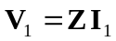, 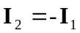

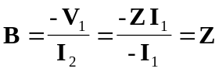

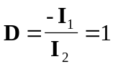

Hence,
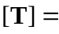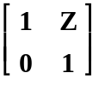

- To find and , consider the circuit in Fig. (c).
+
−
I₁
I₂
+
V₂
−
V₁
(c)

Z

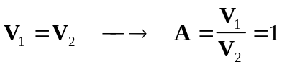

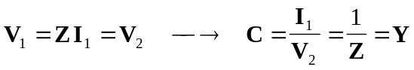

To get and , refer to the circuit in Fig.(d).
+
V₂ = 0
−
I₂
I₁
(d)

Y
+
V₁
−

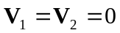

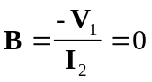,

Thus,
